34. Ecological Communities *(Chapter 53)*

______________________________________________________________________________

I. Introduction

# A. Levels of Organization in Biology

B. Ecological Communities / Ecosystems / Biomes

C. Questions Posed by Community and Systems Ecologists

1. Structure and organization

2. Energy and nutrient inputs

3. Energy and nutrient movement

4. Development of communities through time

5. Effects of human disturbances

II. Community Structure *(1261-1267)*

1. Units and Organizing Forces

-Units = populations organizing traits = population interaction

B. Food Chains and Webs

1. Trophic levels

2. Paths of energy and nutrient movement

-Abiotic conditions

-Disturbance – hurricane, volcanic eruption, invasive pest

-Food web for arctic marine community. At the bottom are photosynthetic organisms (primary producers) which are eaten by (primary consumers) 🡪 (secondary consumers) 🡪 (carnivores)

-Different categories are called tropic levels with arrows pointing form food to feeder

-Some animals feed on multiple levels (omnivores)

-Top carnivore, no other species meet

III. Community Development *(1268-1274)*

-If a community develops on bare ground – primary succession

-If a community develops on group with some vegetation – secondary succession

-Climax community - stable lasting stage of development

-Process that causes succession

-Colonization

-Population interaction

-Some species become locally extinct

A. Terms and Definitions

1. Ecological succession

2. Climax community

3. Processes regulating changes

B. Succession in an Old Field

1. Colonization by dispersing annuals (pioneers)

2. Establishment of perennials

3. Entry of softwoods (after 25 years)

-crowd out pioneers and perennials

-lack of water/acid solid from needles/lack of light

4. Replacement by hardwoods (100 years)

5. Other successional systems

C. Processes Promoting Succession

1. Dispersal abilities and invasion rates

-Differences in dispersal and invasion rates

-Pioneers are generally r-selected species

-Rapid life cycles, produce high numbers

-High levels of dispersal

-Weeds

-Later species are k selected, lower dispersal, slower development, and a longer life cycle

2. Site modification

-Less water, leaves in soil, sunlight, wind, rain hitting the ground 🡪 suitable for other species

-Pioneers/perennials change land to a state the is suitable to others

3. Competition

-Early species driven to local extinction

D. Ecosystem Changes Associated with Succession

1. Soil development

-As plants grow, die, and decay, the soil gets deeper and richer

2. Stratification of vegetation

-Increased height and stratification of vegetation

3. Increased buffering of physical environment

-Temperature, rainfall

4. Increased biomass and productivity

-Photosynthetic active increase as vegetation increases

5. Increased species richness

-Number of species present

6. Reduced rates of species turnover and increased stability

-Turnover is the rate at which new species displaces

-First species have sort life cycles and turn over fast

-Tress turn over very slow

-Leads to the climax community

-Succession occurs in animals, some animals are only around when specific vegetation exists

E. Climax Community

1. Steady state concept

2. Dynamic definition – the addition of a few new individuals does not cause a change in the environment of the community

-Poly-climax

-Geographical heterogeneity (dry peak/wet land) 🡪 different plants

-Local disturbances (hurricanes) 🡪 knock tress down allowing more sunlight to reach the ground 🡪 weeds grow

-

34-1

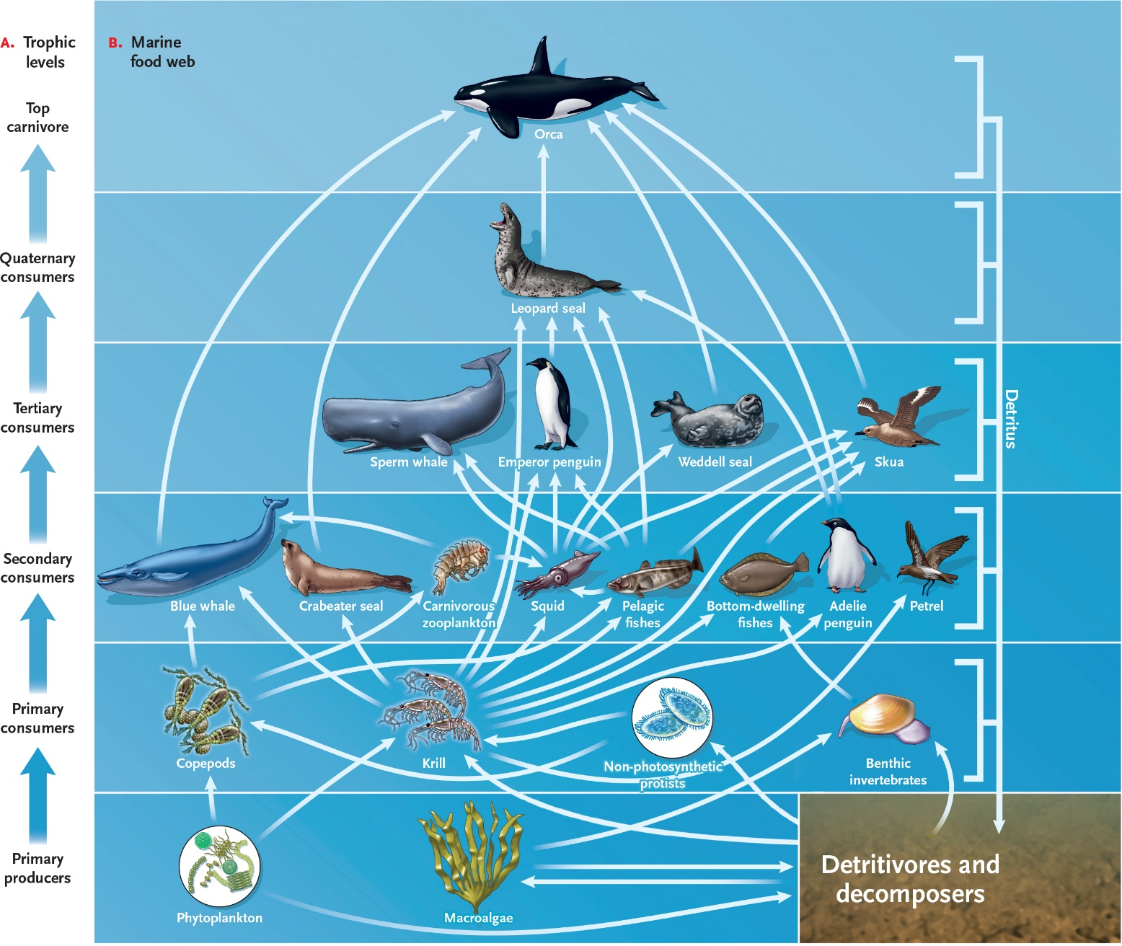

34-2

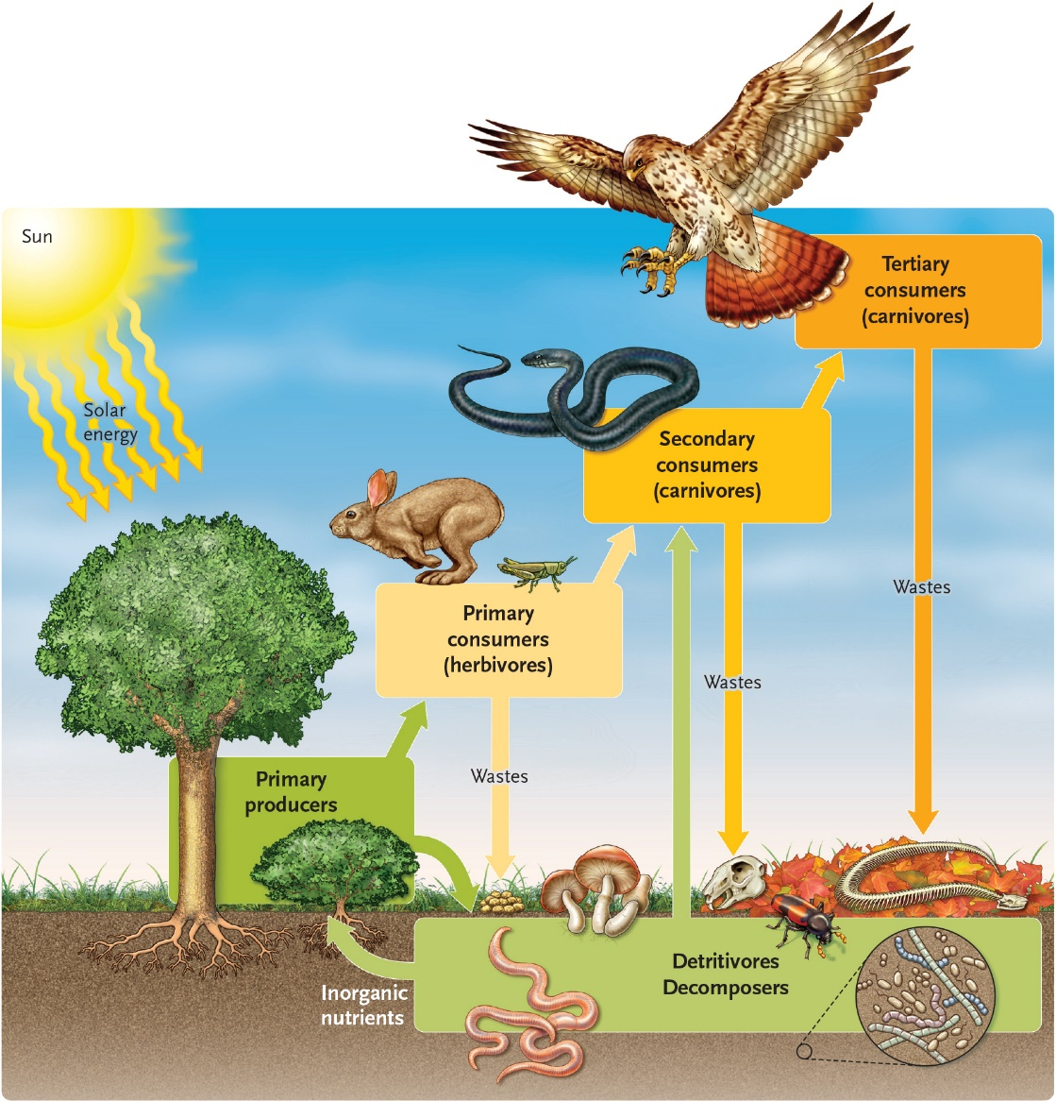

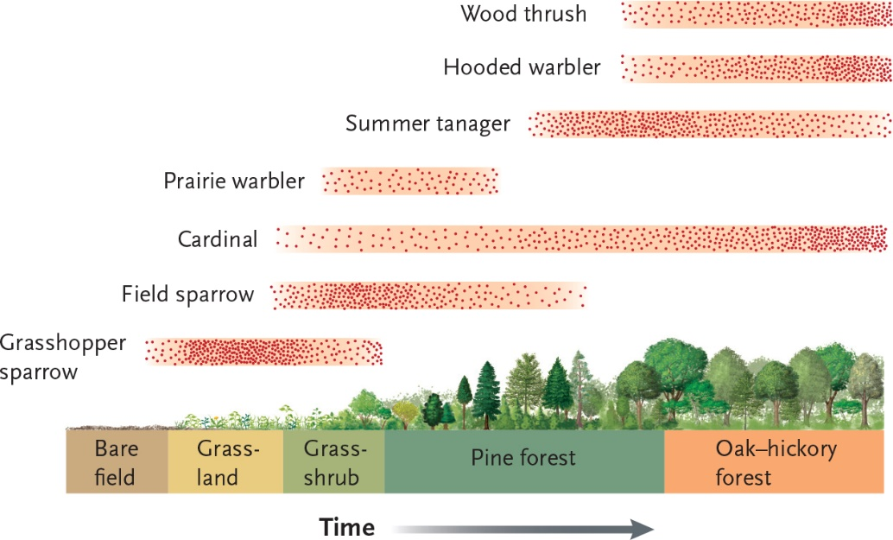

34-3

